

**Faculty of engineering - Shoubra**

**Benha University**

**Research Project / Literature Review**

in fulfillment of the requirements of

|  |  |
| --- | --- |
| **Department** | **Engineering Mathematics and Physics** |
| **Division** | **---------------** |
| **Academic Year** | **2019-2020 preparatory** |
| **Course name** | **Computer** |
| **Course code** | **ECE001** |

**Title: -**

**Artificial intelligence**

By:

|  |  |  |  |
| --- | --- | --- | --- |
|  | Name | Edu mail | B.N |
| 1 | Mina girgis Ebrahim Abdou | Mina196092@feng.bu.edu.eg | 971 |

**Approved by:**

|  |  |
| --- | --- |
| Examiners committee | Signature |
| Dr. Ahmed Bayoumi |  |
| Dr. Shady Elmashad |  |
| Dr. Abdelhamid Attaby |  |

**Research objectives**

* To introduce HTML language.
* To explain the concept of Artificial intelligence.
* To present some application of AI.
* To explain the and show the programmed HTML web page with screenshots and source code.

**Abstract**

Artificial intelligence (AI), deep learning, machine learning and neural networks represent incredibly exciting and powerful machine learning-based techniques used to solve many real-world problems. While human-like deductive reasoning, inference, and decision-making by a computer is still a long time away, there have been remarkable gains in the application of AI techniques and associated algorithms. This report presents an HTML web page about this topic.

**Introduction**

**HTML:**

**HTML** stands for Hyper Text Markup Language. It is used to design web pages using markup language. HTML is the combination of Hypertext and Markup language. Hypertext defines the link between the web pages. Markup language is used to define the text document within tag which defines the structure of web pages. This language is used to annotate (make notes for the computer) text so that a machine can understand it and manipulate text accordingly. Most of markup (e.g. HTML) languages are human readable. Language uses tags to define what manipulation has to be done on the text.HTML is a markup language which is used by the browser to manipulate text, images and other content to display it in required format.

**Artificial intelligence:**

This report attempts to present an overview of Artificial Intelligence (AI). A generally accepted theory that “machine will do and think like humans more in the future” is the concept behind AI. Brief literature of different aspects by which AI is achieved like expert system, knowledge based systems (knowledge engineering), neural networks, fuzzy logic, neuro fuzzy logic and fuzzy expert system, is included in order to have a clear understanding of AI. Along with the different applications of AI, application of expert system to solve the design problem of mechanical spring is also included in this paper. It is concluded that extensive ongoing research in the field of AI gives an idea that in near future a day will come when human beings and machines will merge into cyborgs or cybernetic organisms that are more capable and powerful than either. This idea is called transhumanism.

**Literature Review**

**What is AI?**

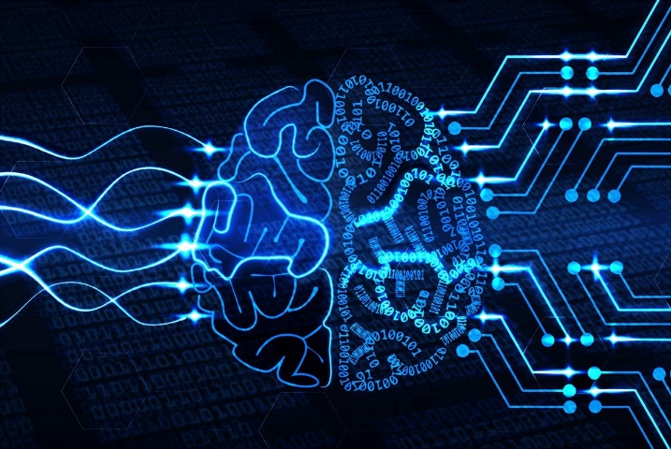Artificial intelligence (AI) is an area of computer science that emphasizes the creation of intelligent machines that work and react like humans. Some of the activities computers with artificial intelligence are designed for include: Speech recognition, Learning, Planning, Problem solving. In this topic we shall discus the following subjects; Deep learning, Machine learning, Computer Programming, Medical field. Deep Learning has enabled many practical applications of Machine Learning and by extension the overall field of AI. Deep Learning breaks down tasks in ways that makes all kinds of machine assists seem possible, even likely. Driverless cars, better preventive healthcare, even better movie recommendations, are all here today or on the horizon. AI is the present and the future. With Deep Learning’s help, AI may even get to that science fiction state we’ve so long imagined. Machine Learning at its most basic is the practice of using algorithms to parse data, learn from it, and then make a determination or prediction about something in the world. So rather than hand-coding software routines with a specific set of instructions to accomplish a particular task, the machine is “trained” using large amounts of data and algorithms that give it the ability to learn how to perform the task. Artificial intelligence is a branch of computer science that aims to create intelligent machines. It has become an essential part of the technology industry. Research associated with artificial intelligence is highly technical and specialized. The core problems of artificial intelligence include programming computers for certain traits such as: Knowledge, Reasoning, Problem solving, Perception, Learning, Planning, and Ability to manipulate and move objects. Knowledge engineering is a core part of AI research. Machines can often act and react like humans only if they have abundant information relating to the world. Artificial intelligence must have access to objects categories, properties and relations between all of them to implement knowledge engineering. Initiating common sense, reasoning and problem-solving power in machines is a difficult and tedious approach.

**Applications of AI:**

* Knowledge reasoning.
* Planning.
* Machine learning.
* Natural language processing.
* Computer vision.
* Robotics.
* Artificial general intelligence.

**Screenshots of the webpage:**

* **Home page(Index):**

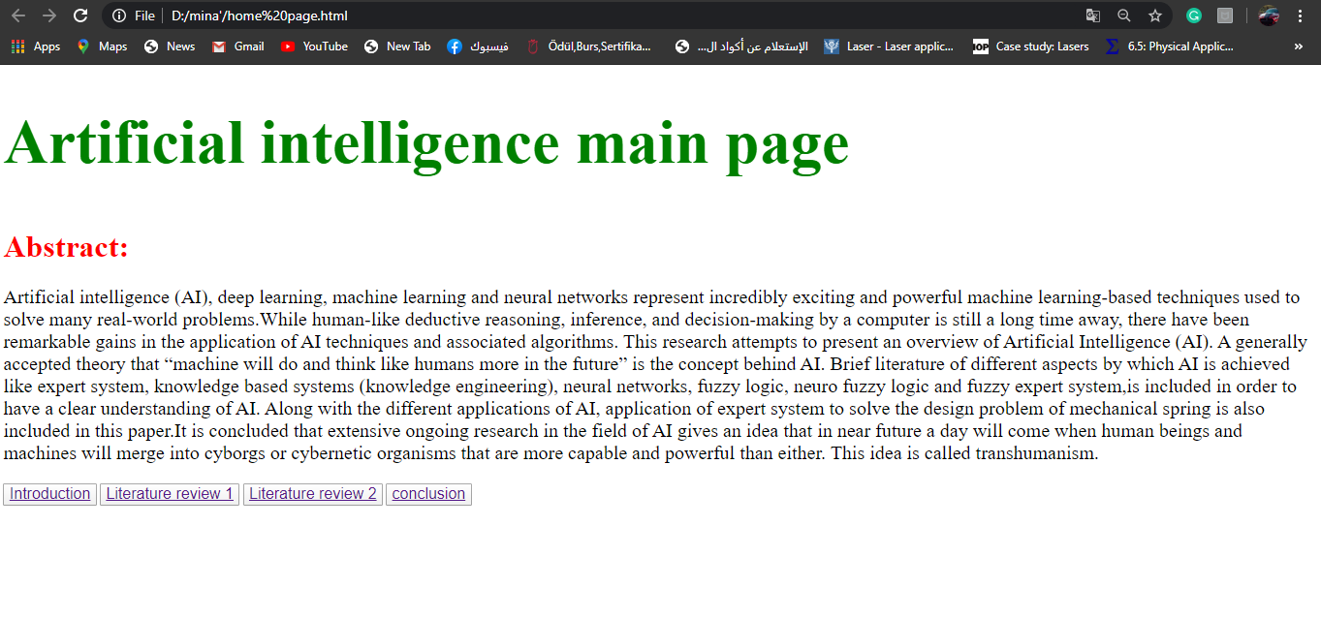it contains an abstract to the topic and it contains the hyperlinks that lead to the other four pages at the bottom.

* **Page1(Introduction):**

It contains an introduction to artificial intelligence and a graphic image for a smart robot: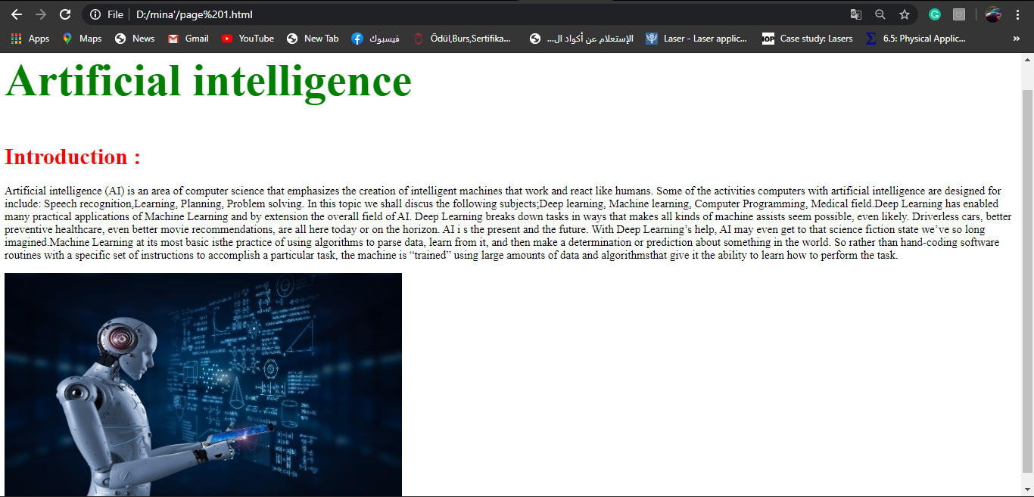

* **Page 2 (Literature review 1):**

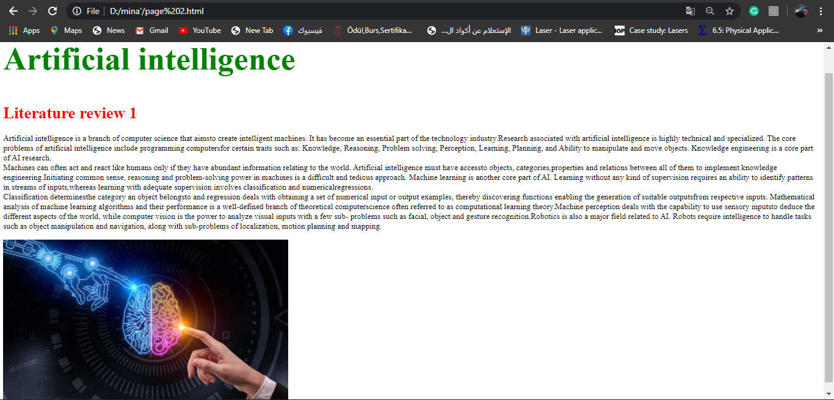It explains the concept of AI in details and some applications on it:

* **Page 3 (Literature review 2):**

It contains the rest of the explanation in addition to a table at the bottom showing the history of AI.

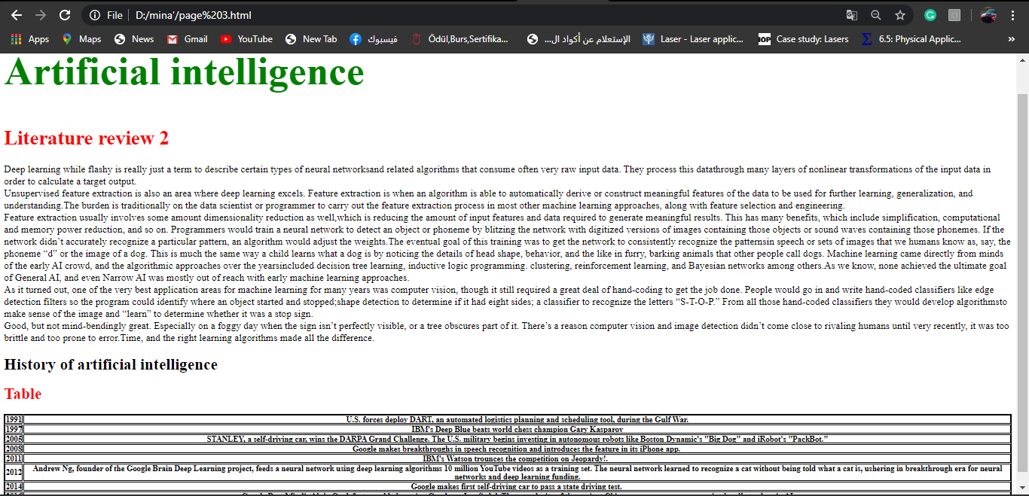

* **Page 4 (Conclusion):**

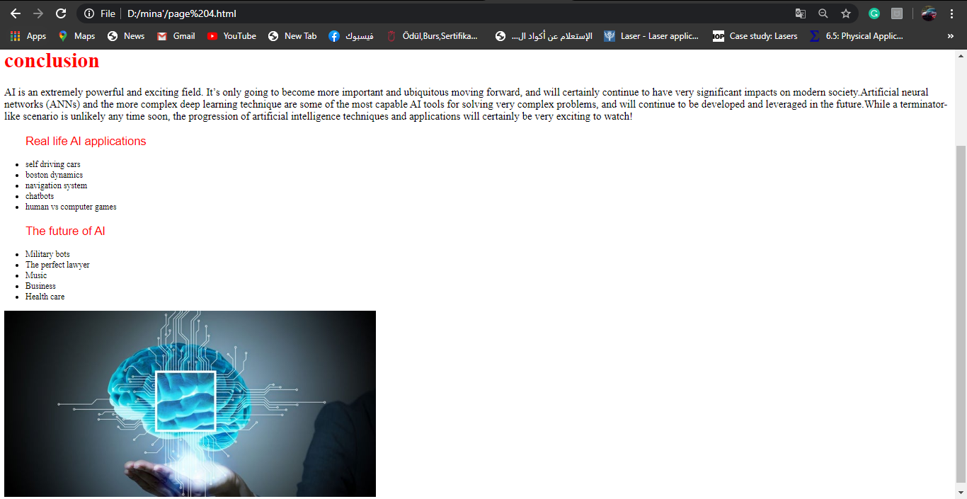It contains the summary of the topic and it contains two lists and one image.

**Source code of the webpage**

* **Main page(Index):**

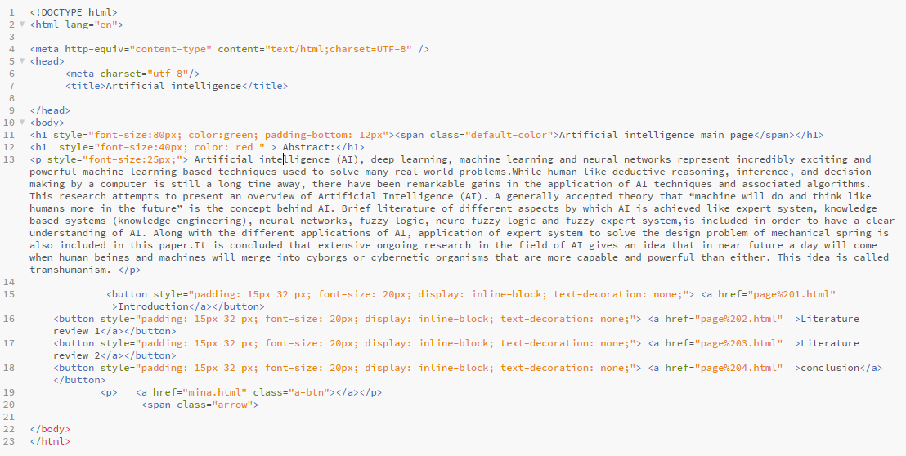

* 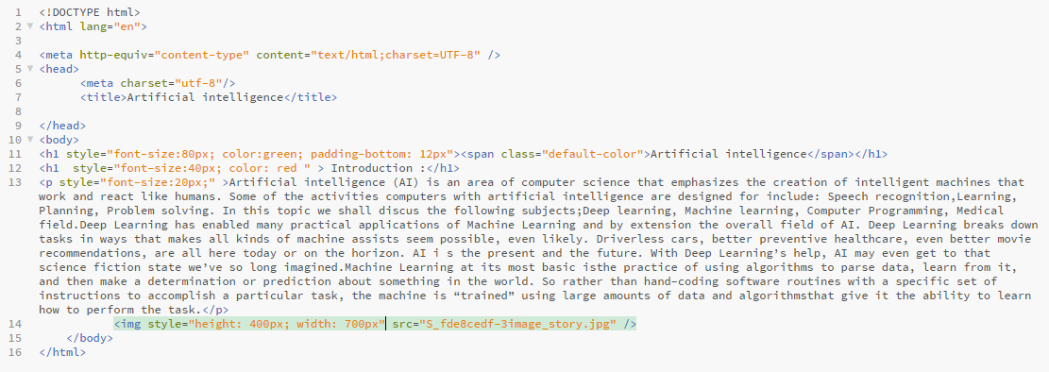**Page1(Introduction):**
* **Page 2 (Literature review 1):**

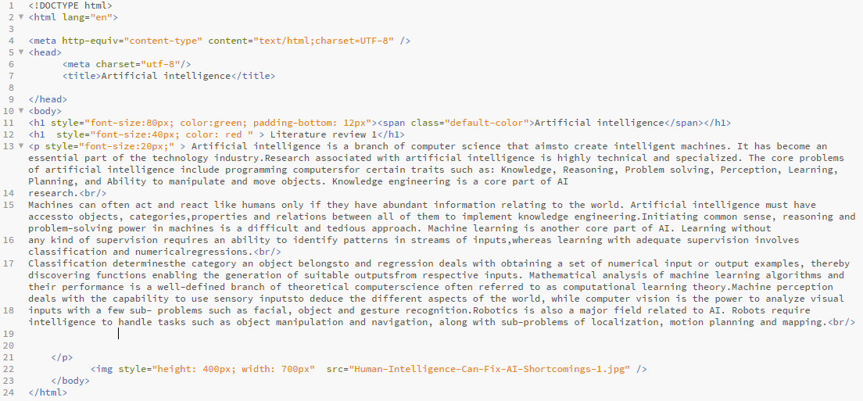

* **Page 3 (Literature review 2):**

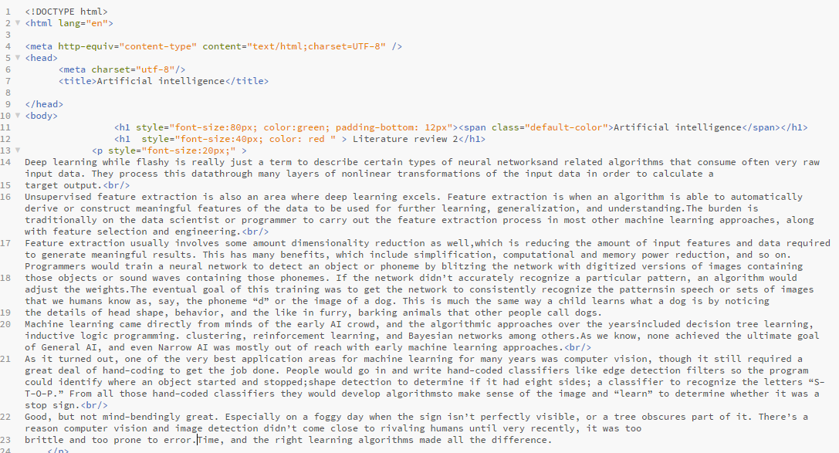

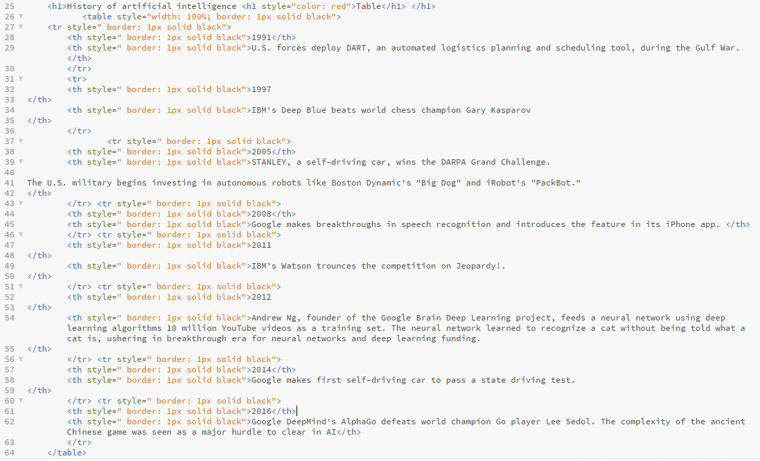

* **Page 4 (Conclusion):**

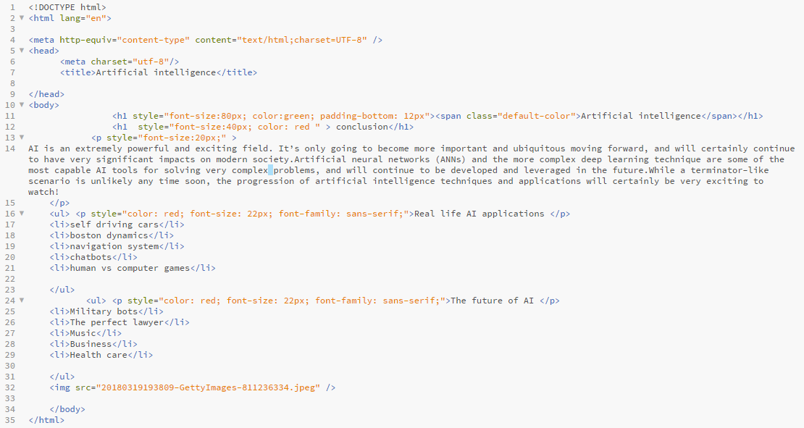

**Conclusion**

AI is an extremely powerful and exciting field. It’s only going to become more important and ubiquitous moving forward, and will certainly continue to have very significant impacts on modern society. Artificial neural networks (ANNs) and the more complex deep learning technique are some of the most capable AI tools for solving very complex problems, and will continue to be developed and leveraged in the future. While a terminator-like scenario is unlikely any time soon, the progression of artificial intelligence techniques and applications will certainly be very exciting to watch.

**References**

* Fay, R. (2017, October 20). The Cyber Security Battlefield. Retrieved May 28, 2020, from <https://www.cigionline.org/articles/cyber-security-battlefield?gclid=Cj0KCQjwwr32BRD4ARIsAAJNf_1flQC0i4WQyVKLD6nL29ESpl-fHtG6smFLVtxuhNwp-zSXFfMfhG0aArUrEALw_wcB>
* Franken field, J. (2020, March 13). How Artificial Intelligence Works. Retrieved May 28, 2020, from <https://www.investopedia.com/terms/a/artificial-intelligence-ai.asp>
* What is Artificial Intelligence? How Does AI Work?: Built In. (2019, June 16). Retrieved May 28, 2020, from <https://builtin.com/artificial-intelligence>
* Goodnight, J. (2016, December 16). Artificial Intelligence – What it is and why it matters. Retrieved May 28, 2020, from <https://www.sas.com/en_us/insights/analytics/what-is-artificial-intelligence.html>